**LAB ASSIGNMENT 2**

**Name** : Umer Khan Wazir , Yusra Fatima

**Reg** **No**: SP17-BCS-098 , SP17-BCS-063

**PART - A:**

|  |  |  |  |  |
| --- | --- | --- | --- | --- |
|  |  |  |  |  |
| **Experiment 1** | 1400 | 1256 | 1360 | // |
| **Experiment 2** | 1116 | 1298 | 1302 | // |
| **Experiment 3** | 1587 | 1256 | 1017 | // |
| **Experiment 4** | 963 | 1231 | 1194 | 1564 |

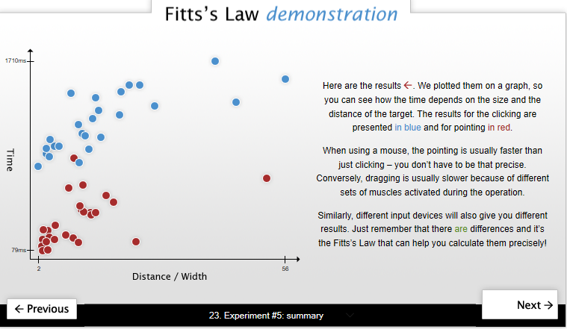

**PART - B:**

We are creating a “Food Delivery Website” for people around Pakistan. Customers can place order through our website, website will provide different popular restaurant options in different cities around Pakistan. People can also apply for job for delivery of food through our website. User can also know about us, contact us and meet our members.

**PART – C**

**People:**

The stakeholders of this project are:

1. Management Team
2. Recruitment team
3. Delivery Boys
4. Customers

Management Team:

Management team will manage the flow of the whole development of the website. Management Team will be able to manage all the orders and the delivery system.

Recruitment Team:

Recruitment team will be able to manage the requests from people who want to join or become a part of this delivery system.

Delivery Boys:

People with age above 18 having driving license can send their job requests.

**Activities:**

Following are the activities involved in our project:

1. User Registration
2. Find Restaurants
3. Food Menu
4. Place order
5. Job Applications

* User Registration:

Customers will register their account to order foods from different restaurants. They can login to their account from anywhere. Customers can be of any age. They can login and from android phones or Pc’s as well. The only thing they need is a good wifi connection.

* Find restaurants:

Customers can find all the restaurants in their respective city that collaborate with our website.

* Food Menu:

Customers can view different kinds of food and their price from the menu of any restaurant they choose.

* Place Order:

Customers can place order from anywhere depending upon whether this website facilitate in that area or not. Customers can add items from menu into the food cart and can also delete any entry before confirming the order.

* Job Applications:

Delivery boys can send job applications through our website to the manager.

Indirect Activities:

* Ratings
* Complaints
* Contact Us

**Context:**

User can use this website at any time any where in Pakistan. Website can be used in any physical environment but the order can be delayed in case of disasters and different weather scenarios but the website can be accessed and order can be played at any environment, it’s the response which can be delayed. Website can also be used in any social environment because we can place order anywhere. It is required that user is connected to internet.

**Technologies:**

User can use our website on both Android and PC. We will create website most probably on word press. It is interactive website and internet connection is must. User can place order and system will show confirmation message of success of order. Content is mostly text and images of food and restaurants. It is website so most people will use PC to place order.